Monthly Performance Report – April 2026
Kestrel Ridge Wind Farm (75.6 MW)
David Chen · 09 May 2026 · KR-OPS-RPT-2026-04

1. Summary
Kestrel Ridge generated 15.6 GWh in April 2026, 6.0 % below the P50 budget of 16.6 GWh. Time-based availability was strong at 97.9 % (contract target 97.0 %). Mean hub-height wind speed of 7.8 m/s was close to the long-term mean (8.0 m/s). Compared with April 2025 (16.0 GWh), output was down 0.4 GWh.
Annual service campaign 2026 started on 13 April with T-01 and T-02.

2. Production and key figures
KPI | April 2026 | Budget / target | YTD 2026 | YTD budget
Net generation (GWh) | 15.6 | 16.6 | 82.0 | 84.7
Time-based availability | 97.9 % | 97.0 % | 96.5 % | 97.0 %
Capacity factor | 28.7 % | 30.5 % | 37.7 % | –
Mean wind speed at hub height (m/s) | 7.8 | 8.0 | – | –
Source: Kestrel Ridge SCADA, revenue meter at 132 kV point of connection. Budget = P50 (2024 post-construction yield assessment).
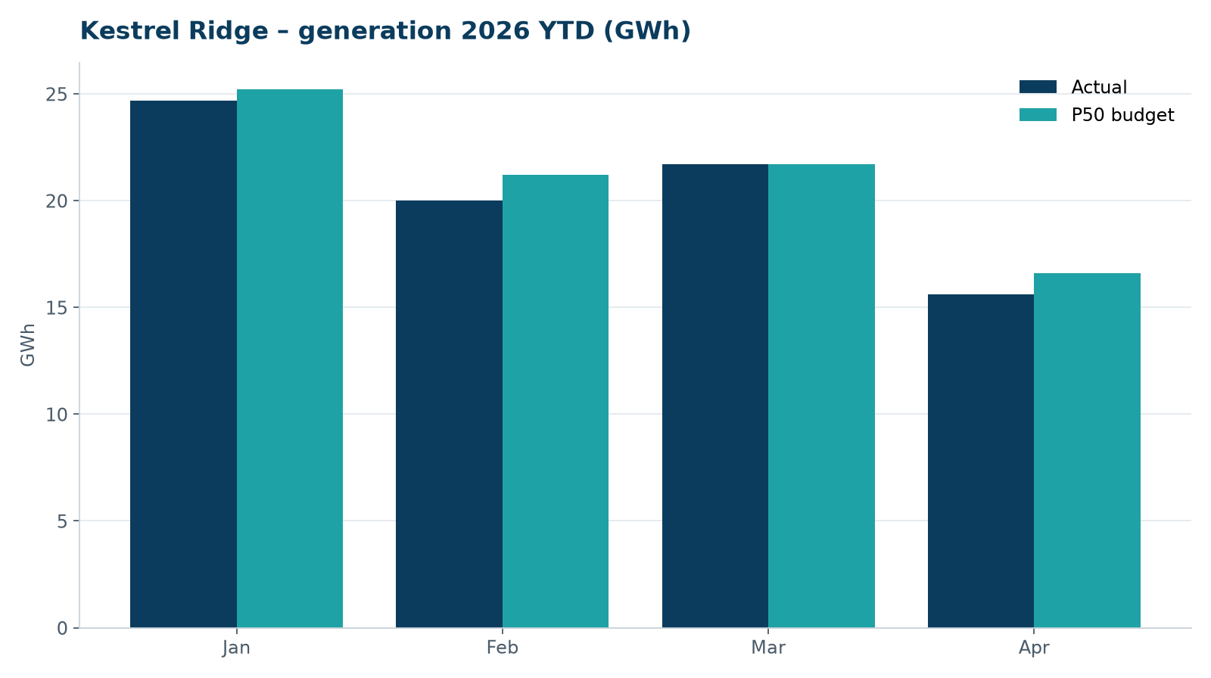
Monthly generation vs. P50 budget, 2026 year to date

3. Availability and downtime
Total turbine downtime attributable to the contractor amounted to 49 turbine-hours for the top events listed below. No grid or force majeure exclusions were claimed this month.
Turbine | Event | Downtime (h)
T-18 | converter fault – IGBT module replaced | 30
T-04 | nacelle cooling fan motor failure | 12
T-05 | hydraulic oil leak at rotor brake caliper | 7
Top downtime events of the month (SCADA event log, reviewed with Highline Wind Services).

4. Maintenance
- Annual service: 3 turbines completed this month.
- 13 corrective work orders closed, 2 still open at month end.
- Site access track inspected; two drainage culverts cleared after heavy rain.

5. Health, safety and environment
Indicator | Month
Hours worked on site (Highline + Weyland) | 4,137
Lost time injuries | 0
First aid cases | 0
Near misses reported | 1
Safety observations | 6
Environmental incidents | 0

No complaints from neighbours were received this month.

6. Outlook
The P50 budget for next month assumes normal seasonal wind; no planned outages beyond routine maintenance.
Prepared by Sara Lindgren (Performance Analyst); reviewed by Ben Okoye (Site Manager) and David Chen (Asset Operations Manager).

